Lab # 02



Fall 2024

**CSE-411L Intro to Game Development Lab**

Submitted by: MUHAMMAD SADEEQ

Registration No.: 21PWCSE2028

Section: C

“On my honor, as a student of the University of Engineering and Technology, I have neither given nor received unauthorized assistance on this academic work”

Submitted to:

Engr. Abdullah Hamid

(27 Oct 2024)

Department of Computer systems engineering

University of Engineering and Technology, Peshawar

1. I create a new Scene with the name Lab 2
2. Then create a terrain size 100x100 height 500
3. And Set the height of Terrain to 250
4. Then created few mountains and a river on the terrain

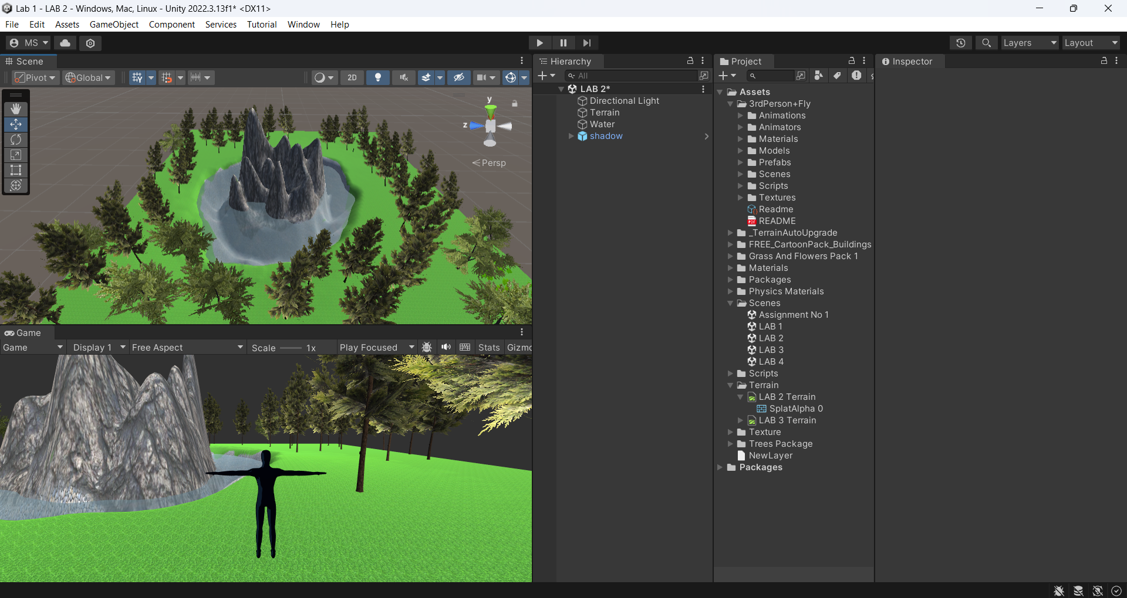

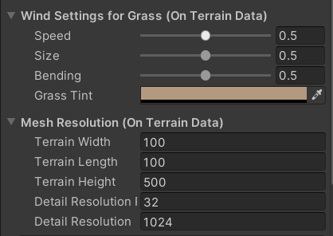

1. Downloaded textures like Grass, Mountain, Stones and water

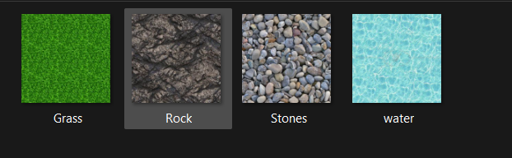

1. Painted the terrain with them

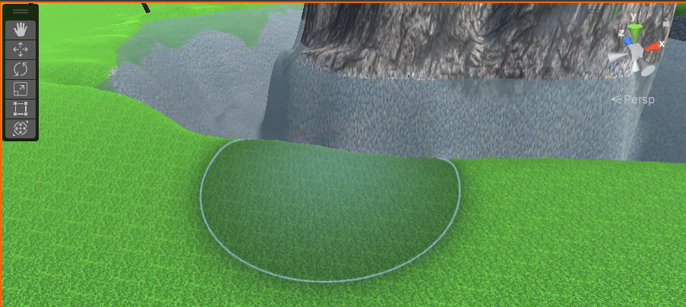

1. Created a water material and apply it to a 3D object like plane and put it on the river to create water effect
2. Changed the water material shader to transparent

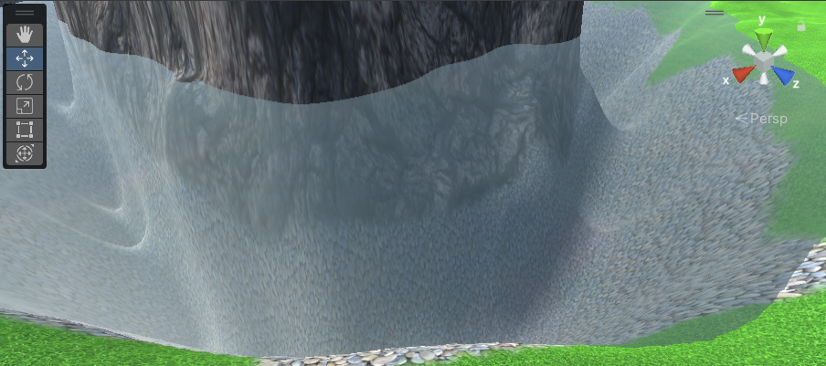

1. Created 3 cubes with 3 different materials of solid colors (Red, Green and Blue) placed them on the terrain.

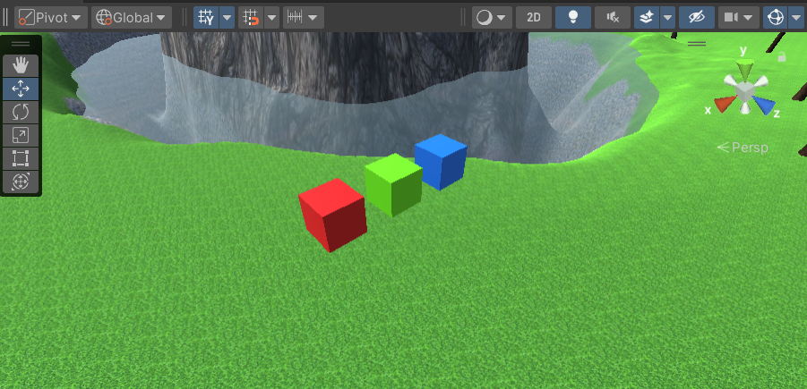

1. Imported the third person package and placed the prefab in the scene and played the game

